Blood Spatter Quiz
Crista Busche
Name the type of blood spatter.

- High Velocity
- Low Velocity
- Arterial Spurt
- Swipe

- 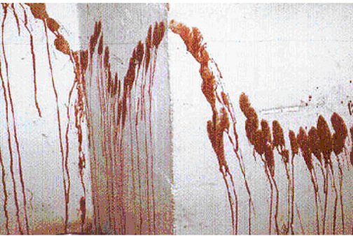
- Low Velocity
- Cast Off
- Arterial Spurt
- Transfer

- 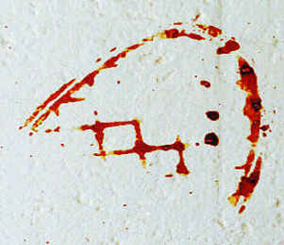
- High Velocity
- Transfer
- Swipe
- Splash Stain

- 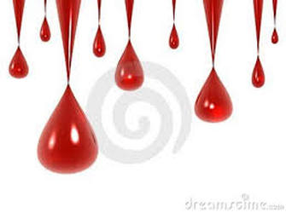
- Splash Stain
- Wipe
- Drip Stains
- Swipe

- Wipe
- Swipe
- Transfer
- Low Velocity

